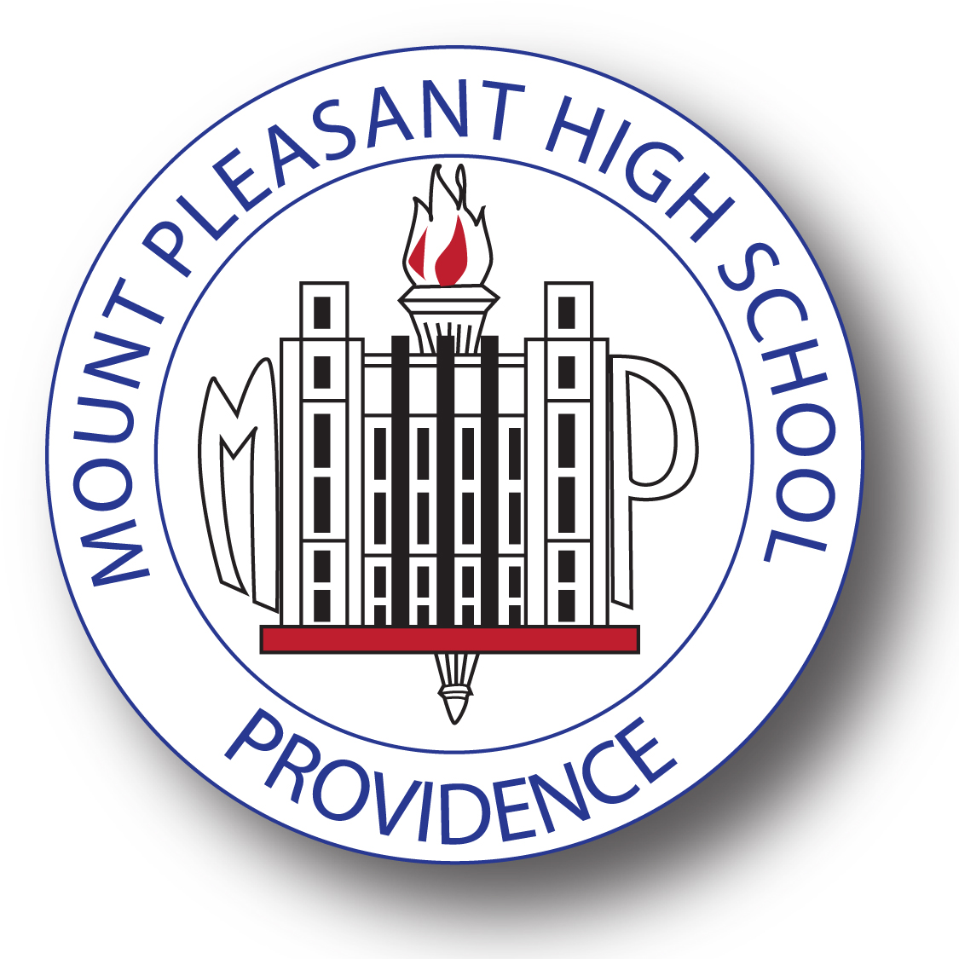

October 11th, 2016,

Dear Parents and Guardians of Mount Pleasant High School,

On **October 19th** all ninth, tenth, and eleventh grade Mount Pleasant students will have the opportunity to take the **PSAT** (Preliminary Scholastic Aptitude Test) a critical first step towards college admittance. Providence Public Schools will be covering the cost of all students to take the test ($80 per student) so that we can track our students’ areas of academic needs for graduation, and continue to prepare them for their future educational experiences beyond high school. This screening will allow us to compare your student to other students in the state and country, and help guide our instruction to best meet your child’s educational needs.

On Wednesday, October 19th, we request that all students be at school by 9:00 a.m. for the normal late start. For participating in the testing all students will be eligible for raffle prizes throughout the day. In addition, all students who take the PSAT will receive a free ticket to Cirque Mechanics Pedal Punk show happening on October 27th at Mount Pleasant High School. The show has been described as, “exceptional, evocative, eye-catching and grossly entertaining…in a word, excellent,” (The New York Times).

Thank you for your time and continued dedication to your student’s education, we look forward to their participation. If you would like any more information on the PSAT, and its importance, please visit the website, *www*.*collegereadiness.collegeboard.org.*

Sincerely,

Christopher Coleman, Principal

Mount Pleasant High School